Fiscal Sponsorship Program

**AREAS OF SERVICE**

BUSINESS ADMINISTRATION

CAPACITY BUILDING SERVICES

FINANCIAL MANAGEMENT

GRANTS ADMINISTRATION

HUMAN RESOURCES

CONTRACT ADMINISTRATION

RISK MANAGEMENT

 Do you dream of more time to focus on your business success while having your finances, grants, human resources, insurance and other administrative needs efficiently managed by a trusted partner?

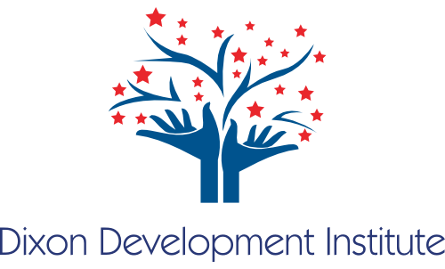

**Dixon Development Institute Fiscal Sponsorship Program can help.**

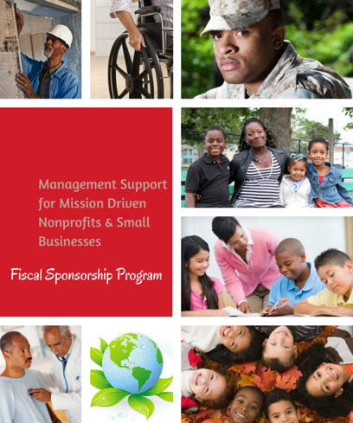

**Project Eligibility Criteria**

After 16 years in business, Dixon & Company created Dixon Development Institute, Inc. in 2015 to address the training, back office, infrastructural challenges that small businesses face. We want to support economic and personal development by supporting small business and non-profits.

**Candidate Compatibility:** Applicants pursuing partnership with DDI must be entrepreneurs, small businesses, or a start-up. Women, Minorities and Veterans are welcome to apply.

**Program Experience:** Staff or volunteers with relevant program experience, to help the project effective pursue its mission.

**Leadership:** An advisory board and an assigned staff member to act as lead liaison for the project.

**Sustainability:** A minimum $75000 in annual funding and the ability to present strategies associated with program implementation.

**Commitment:** To work with the DDI Fiscal Sponsorship Program for at least two years, barring any unforeseen or extraordinary circumstances.

**To Learn More**

* Request an Information Packet
* Receive a One-on-One Consultation
* Schedule a Group Presentation

**Contact**

Renata Dixon, President of Fiscal Sponsorship

Dixon Development Institute, Inc.

PO Box 938, Windsor, CT 06095

860-688-5818, Renatad@Dixondevelop.org

Dixondevelop.org

**CONTRACT ADMINISTRATION**

**Administrative, Management & Shared Services**

**Risk Management & Corporate Support**

* Corporate tax filings
* Property & General Liability Insurance
* Risk management
* Manage contracts/subcontracts
* Provide 501 (c)(3) legal and tax status

**Financial Management**

* Bookkeeping
* Financial audits
* Cash flow projections & contract management
* Grants management
* Monthly financial statements
* Purchasing & bill payment

**Human Resource Management**

* Employee benefits management
* Payroll administration & tax filing
* Consultations on job design, compensation & employee relations

**Organizational Development**

* Organizational assessment
* Discounted professional development trainings

**Projects by Program Area**

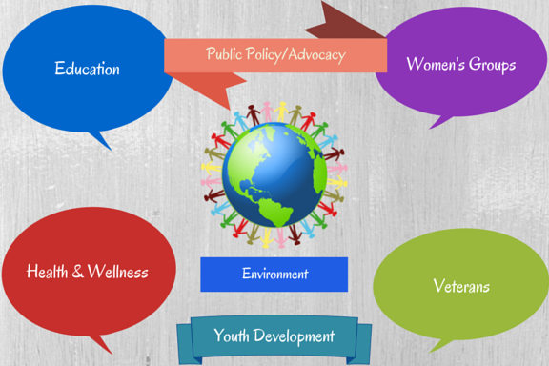

**The Benefits of Fiscal Sponsorship**

DDI’s model of organizing administrative functions to optimize the delivery of cost-effective, flexible, reliable services to all “customers” provides a firm administrative foundation. Our model grooms our clients to become educated in budgeting, planning for expansion, adding additional locations, and becoming ready for dynamic change that will happen in an organization or business. For funders, our Fiscal Sponsorship Program offers a low-risk way to manage initiatives with a high level of regulatory and financial oversight.

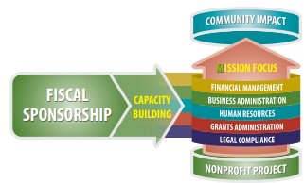

**Partnering with DDI, Inc.**

*Partnerships give a local NGO (non-governmental organization) access to: knowledge and skills; innovative and proven methodologies; networking and funding opportunities; a model for addressing community needs and managing resources; options for organizational management and governance; and strategies for advocacy, government relations and public outreach.* (Counterpart International)

All nonprofits, businesses, organizations, etc. can benefit from capacity building because any one of these groups are seeking new ways to structure their programs to become more efficient without breaking the bank doing so.

DDI Fiscal Sponsorship Program provides a solution that is fresh and unique. Our capacity building partnerships with businesses and nonprofits is an inexpensive, shared service model that is designed to bolster your organization with an integrative approach to management services.

**Fiscal Sponsorship delivers support for nonprofits at any stage of development & growth including:**

* Spinoff programs scaling beyond their startup phase
* Groups forming new nonprofits, coalitions & networks
* Programs in transitions gaining 501(c)(3) status
* Start-up businesses requiring business management and organizational support.